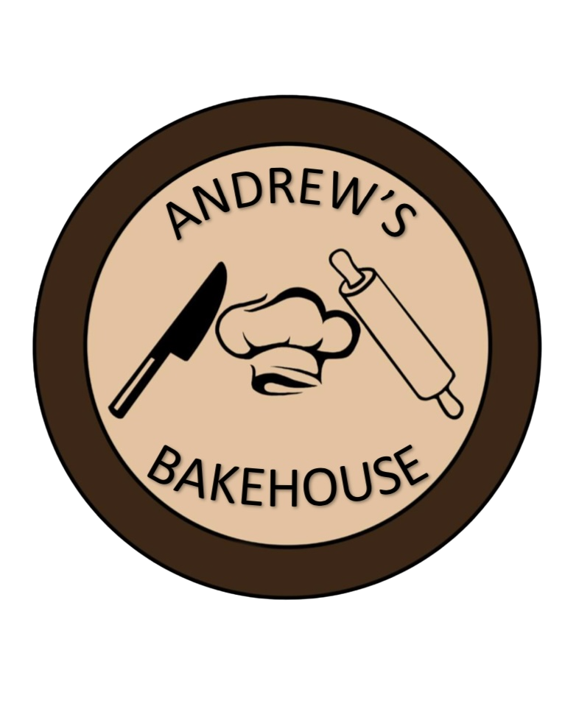
Andrew’s Bakehouse Cake/Cupcake Order Form
Customer Name:__________________________________
Phone Number:___________________________________
Order Date:_____________ Pick-up Date:_______________
Time:_______________________
Item/Size
Sheet Cake __Full Sheet __1/2 Sheet __1/4 Sheet __1/8 Sheet
Round Cakes __8” Double Layer 8” Single Layer
Cupcakes __24 Count __12 Count

Flavors
Sheet Cakes __Yellow __White __Chocolate
Round Cakes __Yellow __White __Chocolate
Cupcakes __Yellow __White __Chocolate

Icing
__Butter Cream __Chocolate Fudge __ Chocolate Cream __Cream Cheese __ Whipped Cream(__Chocolate)

Your bakery order will be confirmed once our Bakers receive your completed form. Payment will be required when we reach out to confirm your order.

If you have question or need assistance please call our Baker Assistants at

